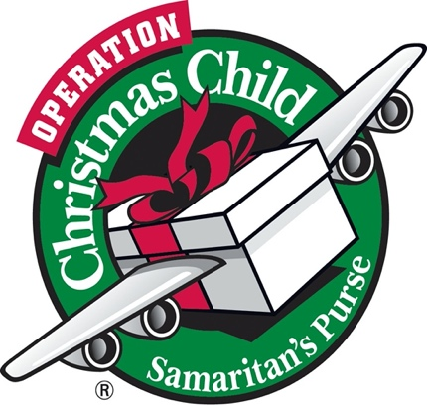

[This Photo](http://geekalabama.com/tag/let-it-snow/) by Unknown Author is licensed under [CC BY-SA-NC](https://creativecommons.org/licenses/by-nc-sa/3.0/)

Operation Christmas Child

Shoebox collection

We will once again be collecting shoeboxes for boys and girls.

You can use your own shoebox or use one of ours.

We fill the boxes with toys, personal hygiene product, arts and crafts, socks, soap, and whatever else you would like.

No liquids or food.

Please turn them in by

November 15th, 2023 to the Family Faith Office.